



**Ars Amatoria**

***Game Design Document***

Copyright - André ‘AnJoMorto’ Fonseca – 2024

Table des matières

Base Summary 3

High Concept 3

Formal Information 3

Overview 3

Gameplay Summary 4

Inspiration 4

Setting 5

Game Design Pillars 6

Design Values 6

Theme and Emotions 6

Player Experience 7

Game Mechanics 7

Demographic 7

UI and Mechanics 8

# Base Summary

## High Concept

A young man uses a time loop, to travel back to the moment before speaking to his crush, armed with the knowledge of each failed attempt.

## Formal Information

**Genre:** Interactive Fiction

**Type:** Text-based Modified Parser

**Players:** Single Player

**Game Length:** Variable, determined by the player’s decisions—subject to final adjustments upon full story completion.

**Platform:** Browser-playable (keyboard [possibly digital included] input essential), hosted on itch.io

**Demographic:** Targeted towards late teenagers and young men shaped by the influences of social media’s dating advice culture.

## Overview

In *Ars Amatoria*, a seemingly simple conversation with a crush, spirals into a disturbing exploration of manipulation and toxic dating advice. This first-person, text-based interactive fiction thrusts players into the role of a young man who, after every failed attempt to win over his crush, goes back in time to a "checkpoint" just before the encounter.

What starts as an innocent attempt to connect with a crush quickly becomes an unnerving experience as the game forces the player to enact behaviours typical of misguided "alpha male" advice found on social media. The narrative, full of short, punchy segments, keeps players constantly typing, searching for the right words to progress, only to find themselves trapped in a loop of increasingly uncomfortable and morally questionable actions.

The game’s innovative parser system, reminiscent of *Hangman* and *Wordle*, offers word recommendations that subtly guide players, making it accessible to those unfamiliar with traditional text-based games.

*Ars Amatoria* is not just a game; it's a commentary on the toxic advice prevalent in today's digital age, making players question their actions and the consequences of following the wrong path. With its roots in Ovid’s ancient pickup advice books and influences from the game *Aisle*, *Ars Amatoria* subverts the flirting game genre, standing out as a disturbing and thought-provoking experience in the world of interactive fiction.

# Gameplay Summary

## Inspiration

*Ars Amatoria* draws inspiration from the unique narrative style of *Aisle* (1999), initially perceived (by me) as a flirting fiction with a twist. However, upon realizing that *Aisle* was not about engaging with the random woman but rather unravelling the protagonist’s fragmented past, there was a sense of awe, followed by small sense of disappointment. The overlapping and inconsistent backstories, while intriguing, left a desire for a more cohesive narrative. What if there was a game that fulfilled this initial expectation—a flirting game where the player must repeatedly engage with the same person, gradually learning what will earn her affection?

*Ars Amatoria* takes this concept and builds upon it, ensuring that with each restart, the narrative remains consistent. The player can use knowledge from previous attempts to improve future interactions. Unlike other games where the reset is merely a gimmick, *Ars Amatoria* weaves this mechanic into the storyline, with time travel serving as the canonical explanation.

However, the flirting game genre is not without its flaws and controversies, and *Ars Amatoria* does not shy away from them. Instead, it amplifies these issues to such an extreme that the player is forced to confront the absurdity and toxicity of such behaviours. This game exaggerates the troubling aspects of dating advice—often propagated by social media “alpha male” influencers—into a dark satire.

The game finds its roots in Ovid’s *Ars Amatoria*, an ancient precursor to modern-day pick-up artist tutorials. Just as Ovid provided men with strategies to seduce women, so too does this *Ars Amatoria*—but with a twist. The game’s seemingly innocent mechanics slowly reveal themselves to be tools of manipulation, forcing the player to partake in actions that, while presented as normal, quickly become unsettling.

By borrowing techniques popular in social media, books, and films, *Ars Amatoria* lures players in with familiar gameplay, only to subvert expectations and expose the underlying darkness of these behaviours. What begins as a light-hearted attempt to win over a crush evolves into a haunting commentary on the pervasive and often harmful dating advice targeted at young men today.

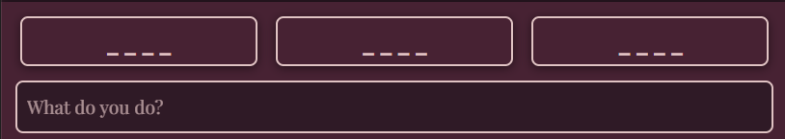

## Setting

The player steps into the shoes of a nervous young man, fresh out of his final exam, caught in the whirlwind of a bustling classroom filled with anxious and relieved students. As he’s about to leave, his gaze locks onto *her*, standing quietly in the corridor. The setting unmistakably signals that her heart is the game’s ultimate goal. The world is deliberately minimalistic, avoiding lengthy descriptions to allow players to project their own recent memories of a school environment—a space all too familiar to the target demographic.

The game begins with a moment of reflection as the following text appears on the screen:

*I stumble one more time out of the final exam, the weight of textbooks finally off my shoulders.*

*There she is, standing in the corridor, the girl I've barely spoken to all semester - if I can even say that now - but I can't get her out of my mind.*

*She's laughing.*

*My heart races; this is my chance, maybe my last chance,*

*once again...*

*one more time...*

Immediately following this introduction, the input bar appears, accompanied by the prompt "*What do you do?*" and a few censored options. This subtle guidance allows players to intuitively understand their next steps without the need for a traditional tutorial. They are naturally encouraged to explore the environment and move toward the girl, who is clearly the focal point of the introductory text.

The girl, at first, is a figure shrouded in mystery, her details sparse. But as the game progresses, players will gradually uncover pieces of her identity—learning about her, bit by bit, as the narrative unfolds.

The time-travel element, however, is left unspoken in the beginning. It’s only as the game restarts, that the cryptic words—

*- if I can even say that now -*

*once again...*

*one more time...*

— begin to make sense. Subtle clues throughout the experience reveal the canonical nature of the game’s rewinds, transforming what first seemed senseless into a poignant revelation.

# Game Design Pillars

**My game design must...**

* **Evoke a persistent sense of unease and discomfort**, ensuring that players are constantly questioning the morality of their actions and the ethical implications of their choices within the game.
* **Create an illusion of control**, where the player can choose from a set of available actions, but the results of these actions are unexpected and discomforting. The game is designed to give the impression of player agency, while in reality, the outcomes are largely predefined, meta-fying the sense of manipulation.
* **Present the game in a typical flirt interactive fiction aesthetic**, with the UI serving to reinforce the appearance of a standard text-based interactive fiction, luring players into a false sense of security before subverting their expectations with darker themes.
* **Exaggerate the genre’s tropes to their absurd extremes**, using the familiar mechanics of flirting games to critique and denounce the toxic influences of modern social media culture.
* **Encourage players to explore multiple paths**, forcing them to confront the ethical ramifications of their actions as they attempt to find a way to seduce the girl. By the end of the game, players should feel a deep sense of unease, realizing that their persistence led to unethical manipulation rather than genuine connection.

# Design Values

## Theme and Emotions

The central theme of the game revolves around flirtation and pick-up art, underpinned by darker elements of manipulation, toxicity, and the consequences of following questionable advice found on the internet. The narrative delves deep into the interactions between the main character and the world, particularly focusing on their attempts to engage with a girl character. The theme is not veiled in metaphor; instead, it is presented in a direct, almost abrasive manner that strips away any pretence, leaving the raw and often uncomfortable truths about these practices exposed.

The aim is to evoke a range of emotions, from initial curiosity and engagement to deep discomfort, disgust, and self-reflection. Players may find themselves questioning their choices and feeling a sense of guilt or disappointment, particularly as they realize the extent to which they have related to, or even participated in, the actions of the character they control. By the end of the game, the intended emotional response is one of disillusionment and introspection, as players come to terms with the unsettling implications of their in-game behaviour.

## Player Experience

Players are encouraged to experiment by inputting different words until viable options are revealed, fostering a sense of curiosity and exploration. The results of the player's decisions often do not always align with their expectations, a - while sometimes inadvertently - common trope in multiple-choice interactive fictions, which amplifies feelings of confusion, disgust, and unease.

Choices are a fundamental aspect of the game, with decisions occurring frequently and drastically altering the course of the narrative. To prevent frustration and monotony, the game is structured to keep interactions brief and impactful, with resets occurring after only a few decisions. This design choice ensures that players remain engaged without feeling overwhelmed, and it helps to maintain a sense of momentum despite the frequent restarts.

The game is designed to be played in long, uninterrupted sessions, allowing players to fully immerse themselves in the narrative and retain crucial information between resets. The capacity to memorise information is central to this experience, as the game requires players to remember previous choices and outcomes to explore new paths effectively. Taking breaks may diminish the player’s ability to progress, as forgotten details could lead to repetition and frustration.

## Game Mechanics

The game introduces a novel mechanic inspired by games like *Hangman* or *Wordle*. Players are faced with a series of censored options, where each letter they input gradually unveils the corresponding letters within the available actions, slowly piecing together the choices. This system serves as an entry point for those unfamiliar with parser-based games, making the experience more intuitive and minimizing the frustration often associated with guessing commands. Complementing this, the time-loop mechanic heavily inspired by *Aisle* weaves the narrative thread of manipulation seamlessly into the gameplay. Each chosen action becomes permanently visible after initial selection, ensuring that players are not bogged down by the repetitive task of retyping the same option, keeping the gameplay smooth and focused on discovery.

## Demographic

The target audience for the game is primarily male youth, particularly those in their late teens to early adulthood who are just beginning to navigate “serious relationships.” However, the game also has broader appeal to those curious about the toxic behaviours it critiques but does not aim to be played by the largest possible audience. The game is intended to be discovered on platforms like *itch.io*, though its reach may be limited to the school context and/or my immediate social circle.

The game is deeply rooted in contemporary social media culture, particularly the TikTok era and the proliferation of short-form content. However, the toxic behaviours it critiques—such as the manipulative techniques of “pick-up artists”—are timeless, lending the game a sense of both modernity and enduring relevance.

# UI and Mechanics

The UI embraces a clean, minimalist design. The story is presented within an 800px-wide column, centred on the screen—a subtle nod to the simplicity of classic HTML layouts. However, the choice of font (*Playfair Display*), along with the rounded edges and carefully selected colours, lends the game a more modern and refined aesthetic.

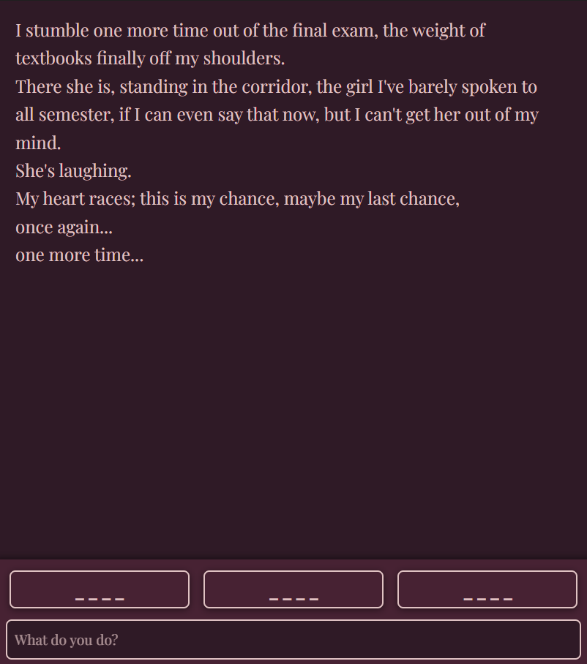

The primary colour scheme leans into the classic rose tones, reinforcing the flirtation theme:

* #2f1a26 and #472233 for the background
* #e0c3c3 and #b39b9b for the text and accents
* #e70053 for contrast

In addition, the game alternates with a blue colour palette (#203f4f/#337b7b, #d1ecf1/#a9d6e5 and #41ffff) with each time-loop reset. This dynamic shift in colour not only keeps the repetitive gameplay visually engaging but also subtly reinforces the canonical nature of the time-loop within the game’s aesthetics.

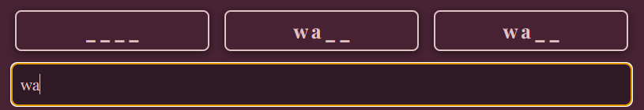

As players type letters into the input bar, any matching letters in the hidden options are revealed, progressively uncovering the full word. A character limit based on the longest possible word ensures that players can’t simply input the entire alphabet to brute force the answers.

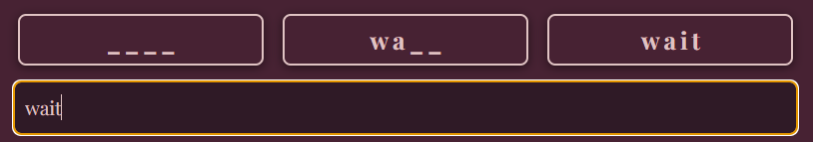

Once a word is fully revealed, it transforms into a clickable button, allowing the player to select it in future loops without retyping. Alternatively, players can manually type and confirm a valid word by pressing *Enter*.

As the game progresses, new segments of the story are added beneath the current text, which is scrollable, letting players review the entire narrative path leading up to the reset. This approach makes the progression clear and fluid, while keeping players engaged with each loop.

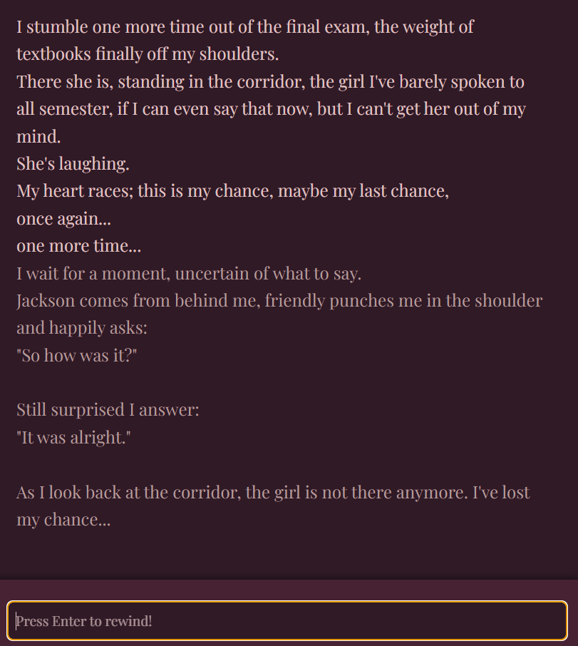

The game will typically go as such:

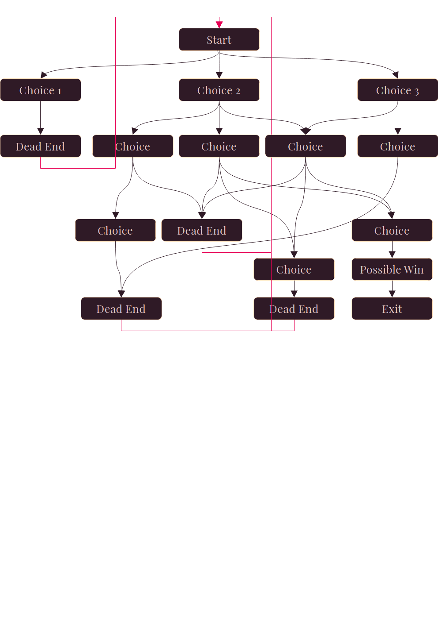

- Public cible

- Le public risque de ne pas les voir comme absurde, très difficile -- les gens ne voient pas l'aspect problèmatique

- Bloquer/Cacher certains choix selon les éléments déjà trouvés

- Régler

- Il faut maitriser chaque scénario, le public cible et son attitude par rapport au jeu --> premier ou second degré

- Éviter le cringe et bcp tester avec des proches

- La satire vient du paradox de la logique pick-up qui vise à objectifier et le faire à pkusieurs femmes et viser le coeur de quelqu'un pour qui on a des sentiments

- Le personnage il faut qu'il commence à être conscient sur ce qu'iil fait --> réaction brutale du crush mais aussi du personnage qu'on incarne

- Le choix de avoir que des fins absurdes --> la logique pickup est sans issue ou aller à l'enconte du système et faire une fin romantique

- Possibilité de jouer avec le système Hangman

- Référence directe --> Save The Date <https://paperdino.com/save-the-date/>

- Inspiration : Ta présentation m'a fait penser à cette épisode de podcast. Ca pourra peut-être t'inspirer ? <https://www.binge.audio/podcast/apreslapluie/jai-cru-a-lideologie-incel>

Esprit d'escalier pour André : j'ai oublié une remarque par rapport ton GDD : au vu du public, je ne suis pas sür que Ars Amatoria soit le bon titre. Je comprends la référence Ovide, mais c'est peut-étre un peu trop obscur. Å réinterroger un peu plus tard. Le titre me semble d'autant plus important qu'il va permettre de toucher le public cible (pas sür que les pick-up artists cliquent sur Ars Amatoria; alors que PUA Simulator Bien moins classe évidemment, mais peut-étre plus efficace pour le rejoindre).

